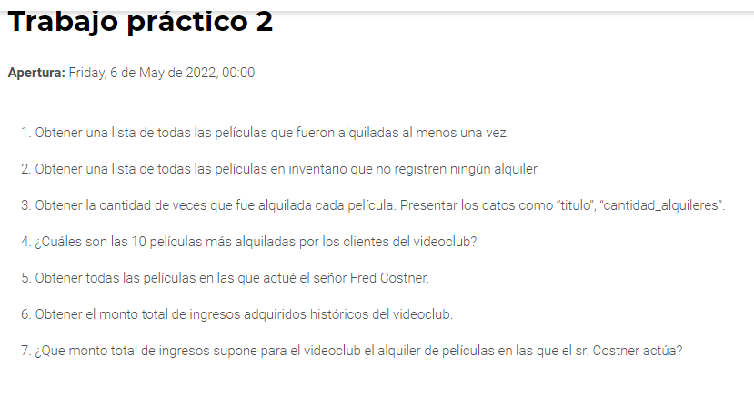

1 [SELECT](http://localhost/phpmyadmin/url.php?url=https://dev.mysql.com/doc/refman/8.0/en/select.html) title

from film

WHERE film_id [in](http://localhost/phpmyadmin/url.php?url=https://dev.mysql.com/doc/refman/8.0/en/comparison-operators.html%23function_in) ([SELECT](http://localhost/phpmyadmin/url.php?url=https://dev.mysql.com/doc/refman/8.0/en/select.html) film_id

from inventory

WHERE inventory_id [in](http://localhost/phpmyadmin/url.php?url=https://dev.mysql.com/doc/refman/8.0/en/comparison-operators.html%23function_in) ([SELECT](http://localhost/phpmyadmin/url.php?url=https://dev.mysql.com/doc/refman/8.0/en/select.html) inventory_id from rental));

2

[SELECT](http://localhost/phpmyadmin/url.php?url=https://dev.mysql.com/doc/refman/8.0/en/select.html) title

from film

WHERE film_id [not](http://localhost/phpmyadmin/url.php?url=https://dev.mysql.com/doc/refman/8.0/en/logical-operators.html%23operator_not) [in](http://localhost/phpmyadmin/url.php?url=https://dev.mysql.com/doc/refman/8.0/en/comparison-operators.html%23function_in) ([SELECT](http://localhost/phpmyadmin/url.php?url=https://dev.mysql.com/doc/refman/8.0/en/select.html) film_id

from inventory

WHERE inventory_id [in](http://localhost/phpmyadmin/url.php?url=https://dev.mysql.com/doc/refman/8.0/en/comparison-operators.html%23function_in) ([SELECT](http://localhost/phpmyadmin/url.php?url=https://dev.mysql.com/doc/refman/8.0/en/select.html) inventory_id from rental));

Cambia el NOT IN en el primer in nomas

3

[SELECT](http://localhost/phpmyadmin/url.php?url=https://dev.mysql.com/doc/refman/8.0/en/select.html) title, [COUNT](http://localhost/phpmyadmin/url.php?url=https://dev.mysql.com/doc/refman/8.0/en/aggregate-functions.html%23function_count)(*) as cantidad_alquileres

from film, inventory,rental

WHERE film.film_id = inventory.film_id [and](http://localhost/phpmyadmin/url.php?url=https://dev.mysql.com/doc/refman/8.0/en/logical-operators.html%23operator_and) inventory.inventory_id = rental.inventory_id

GROUP BY title;

4

SELECT title, COUNT(*) as cantidad_alquileres

FROM film, inventory,rental

WHERE film.film_id = inventory.film_id and inventory.inventory_id = rental.inventory_id

GROUP BY title

ORDER by cantidad_alquileres DESC

LIMIT 10;

5

SELECT title

FROM film

WHERE film_id in (SELECT film_id

FROM film_actor

WHERE actor_id in (SELECT actor_id

FROM actor

WHERE first_name = 'FRED' AND last_name = 'COSTNER'));

6

SELECT SUM(amount) as TotalIngresosAdquiridosHistoricos

FROM payment;

7

SELECT SUM(amount) as Total_ingresos_x_peliculas_de_FREDCOSTNER

FROM payment

WHERE rental_id in (SELECT rental_id

FROM rental

WHERE inventory_id in (SELECT inventory_id

FROM inventory

WHERE film_id in (SELECT film_id

FROM film_actor

WHERE actor_id in (SELECT actor_id

FROM actor

WHERE first_name = 'FRED' AND last_name = 'COSTNER'))));